HIMSS26 Electronic Message Billboard Locations/Images
- Event Directory Boards – 6
  - Level 1 – Outside of Marco Polo Ballroom
  - Level 3 – Outside of Murano Ballroom
  - Level 3 – Transition from Canal Shoppes to Venetian Convention Center
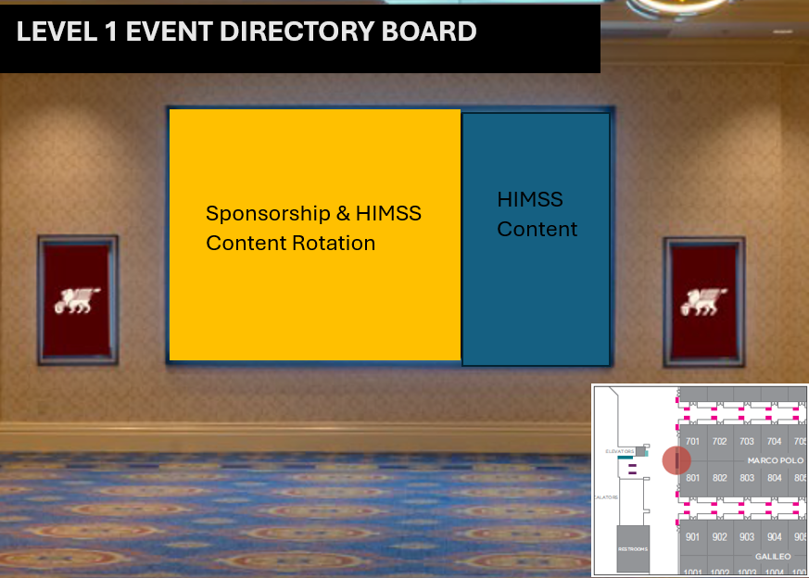

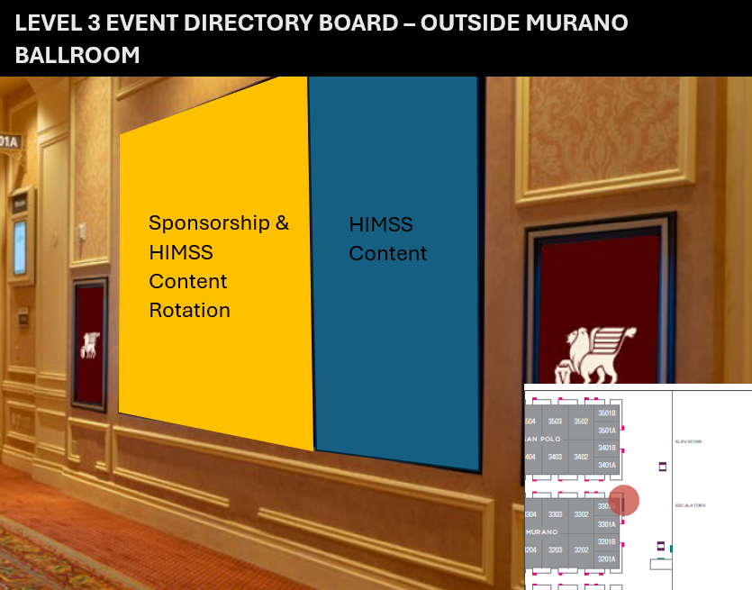
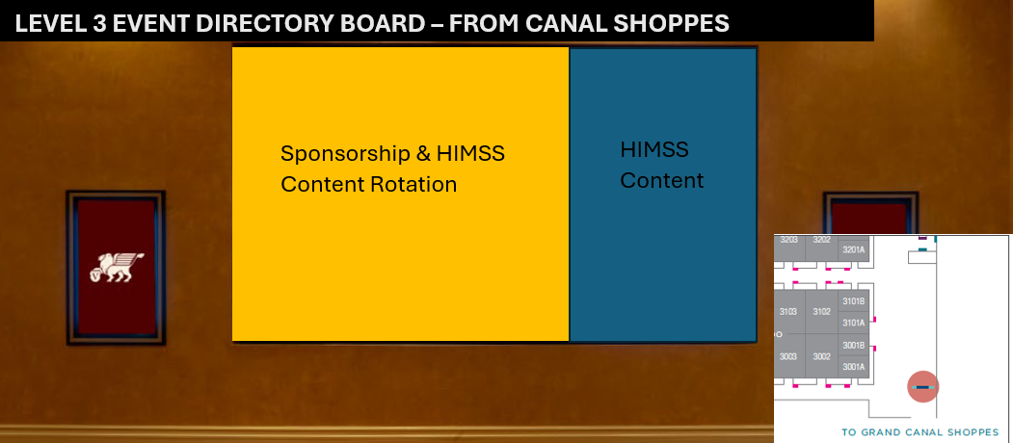

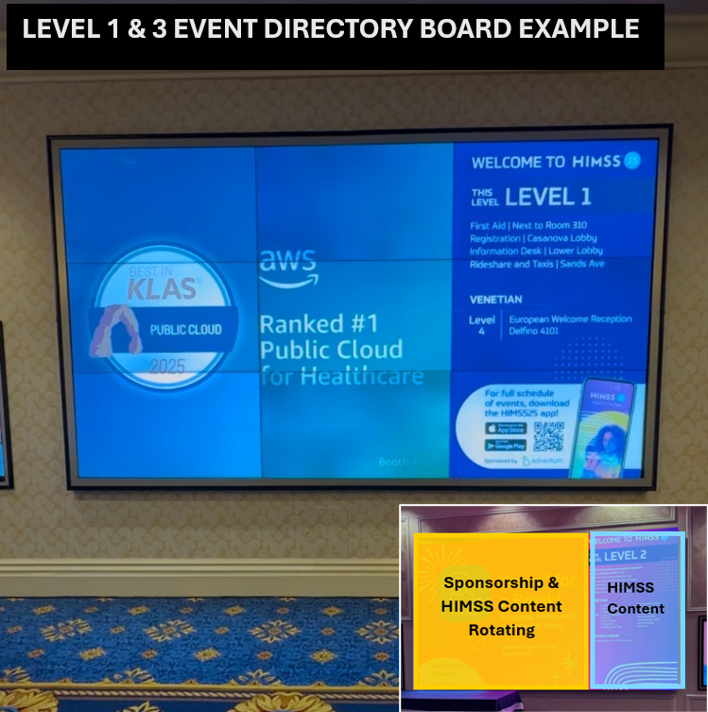

  - Level 2 – Outside of Titian Ballroom
  - Level 4 – Outside Lando Ballroom
  - Level 5 – Across from Palazzo Ballroom

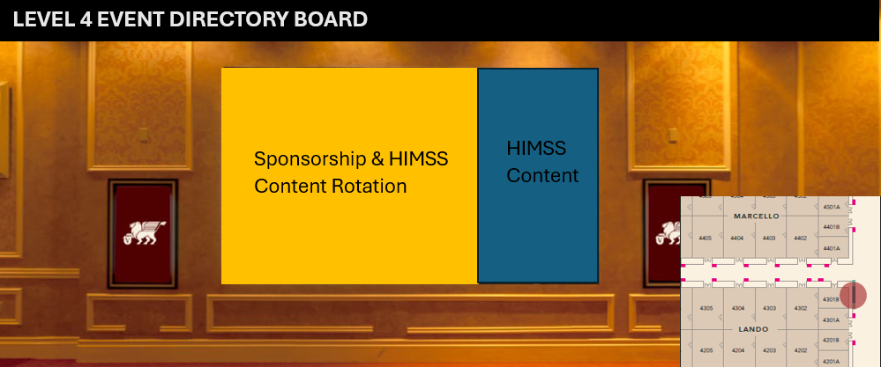
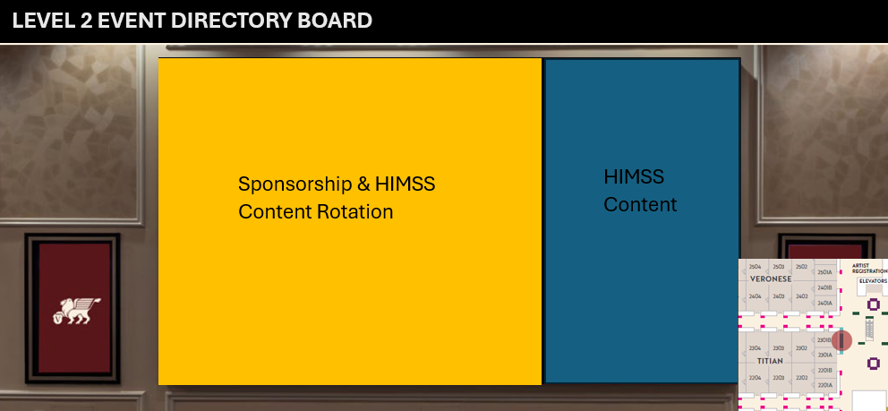

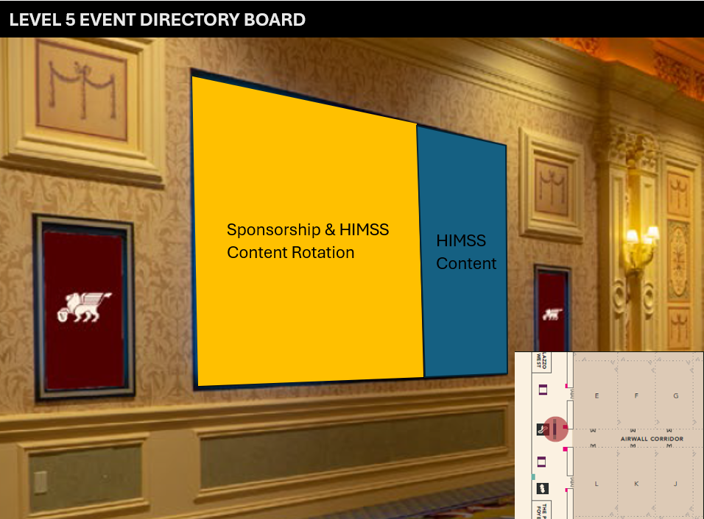

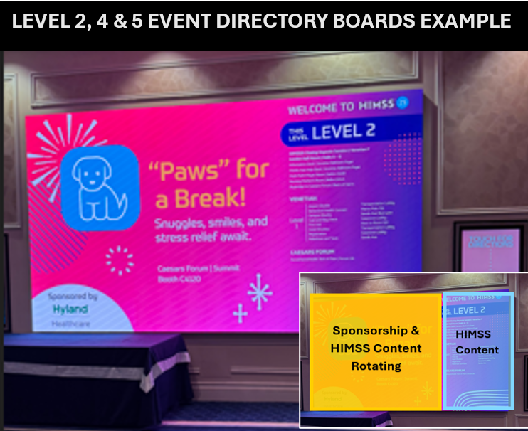
- Level 2 - Overhead at the exit of Venetian Convention Center to the hotel

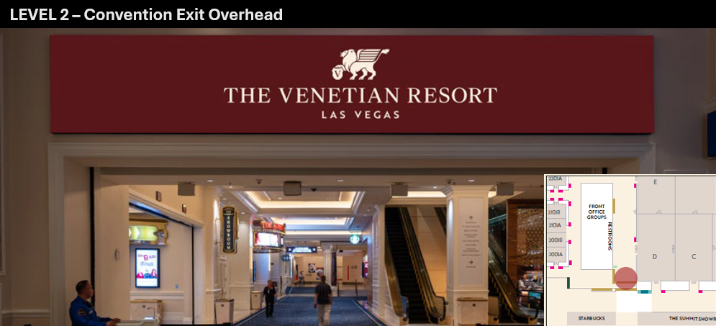

- Level 2 – Over escalators off main Venetian Expo Center concourse leading to Upper Expo Lobby and Conference Sessions

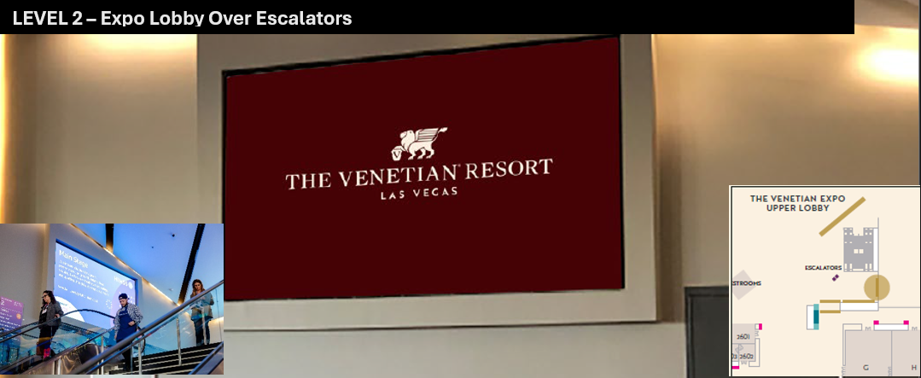

- Level 2 – Over escalators in Venetian Convention Center to/from Level 1 and Transportation Lobby
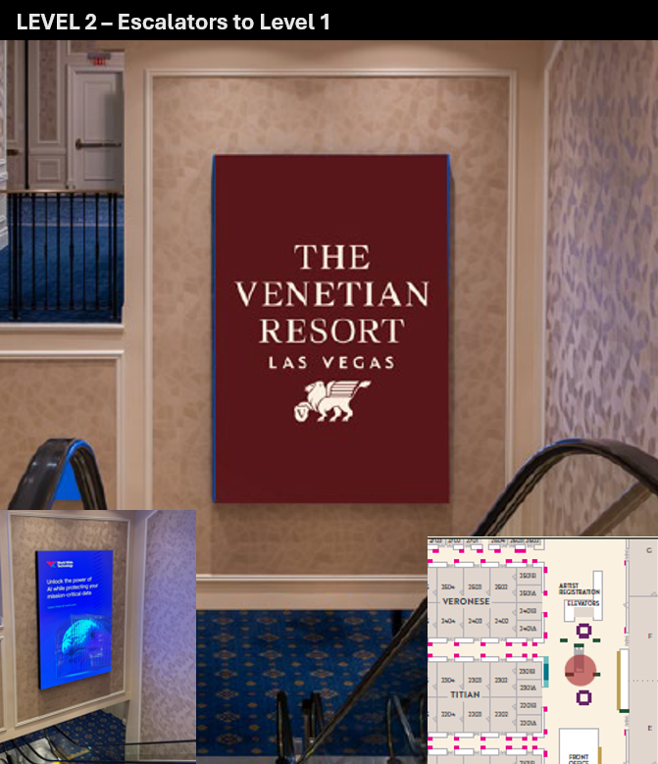

- Level 2 – Transition from Venetian Convention Center main hallway to Upper Expo Lobby
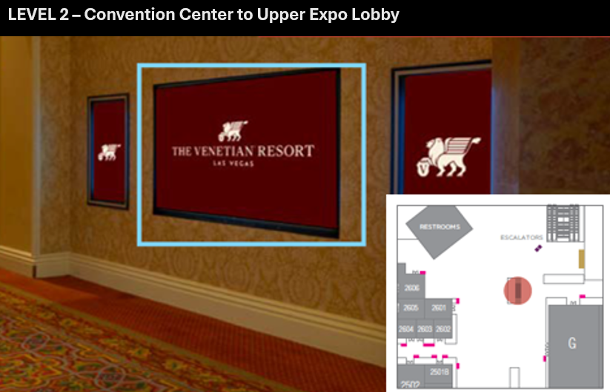

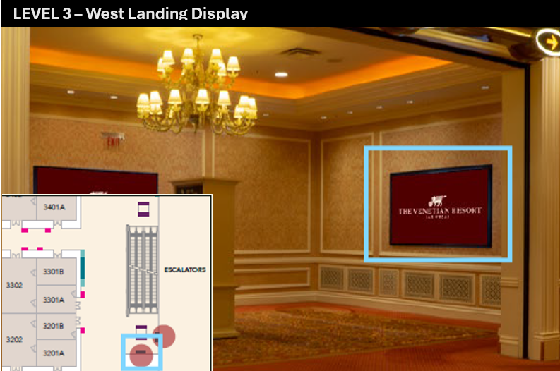
- Level 3 - Venetian Convention Center west landing at top of escalators

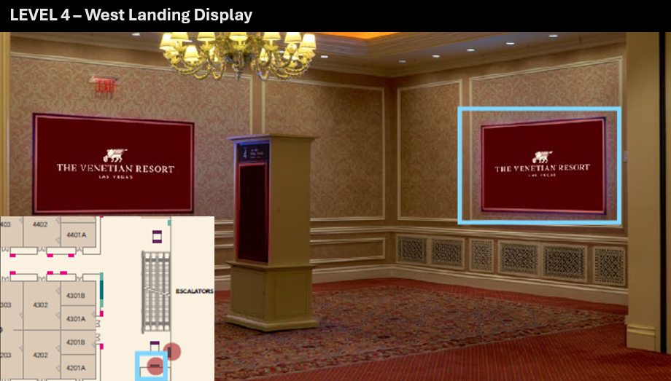
- Level 4 - Venetian Expo Center west landing at top of escalators
- Level 4 – (3) Hall Entrance Displays leading to conference meeting rooms in main lobby space
